#TERRAFORMBLOCK-------------------------

Terraformblock.tf

terraform {

required_providers {

aws = {

source = "hashicorp/aws"

version = "5.62.0"

}

}

}

#PROVIDER BLOCK--------------------------------

Provider.tf

provider "aws" {

region = "us-east-1

}

#RESOURCE BLOCK-------------------------------

main.tf

#VPC----------------------

resource "aws_vpc" "harsha-project"{

cidr_block = "10.0.0.0/16"

tags = {

name = "vpc_project"

}

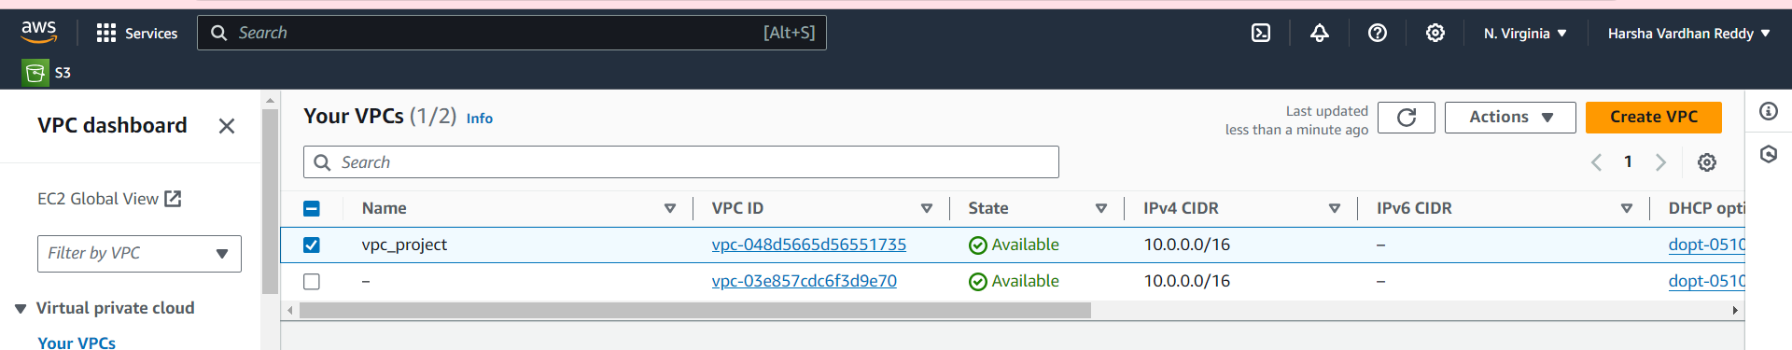

#PUBLIC_SUBNETS_1----------------

resource "aws_subnet" "public_subnet_1" {

vpc_id = aws_vpc.harsha-project.id

cidr_block = "10.0.0.0/24"

map_public_ip_on_launch = "true"

availability_zone = "us-east-1a"

tags = {

Name = "project_public_subnet_1"

}

}

#PUBLIC_SUBNETS_2-------------------

resource "aws_subnet" "public_subnet_2" {

vpc_id = aws_vpc.harsha-project.id

cidr_block = "10.0.1.0/24"

map_public_ip_on_launch = "true"

availability_zone = "us-east-1b"

tags = {

Name = "public-subnet2"

}

}

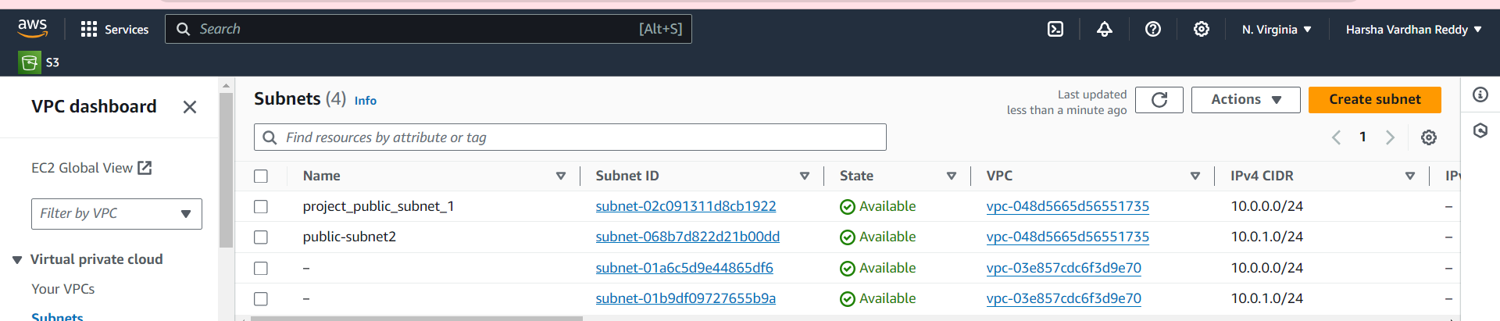

# INTERNET GATEWAY-----------------------------------------------

resource "aws_internet_gateway" "internet_gateway" {

vpc_id = aws_vpc.harsha-project.id

tags = {

name = "project-igw"

}

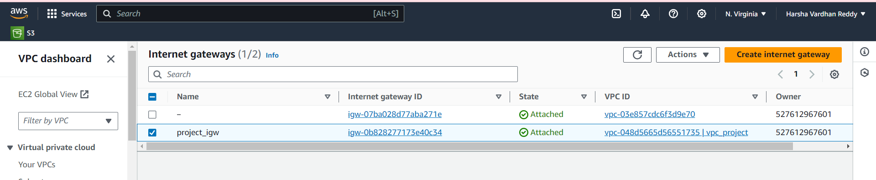

# ROUTE TABLE -------------------------------------------

resource "aws_route_table" "route_project" {

vpc_id = aws_vpc.harsha-project.id

route {

cidr_block = "0.0.0.0/0"

gateway_id = aws_internet_gateway.internet_gateway.id

}

tags = {

Name = "route to internet"

}

}

# ROUTE TABLE ASSOCIATION------------------------------------

resource "aws_route_table_association" "route_table_harsha" {

subnet_id = aws_subnet.public_subnet_1.id

route_table_id = aws_route_table.route_project.id

}

#route 2

resource "aws_route_table_association" "route_table_harsha_1" {

subnet_id = aws_subnet.public_subnet_2.id

route_table_id = aws_route_table.route_project.id

}

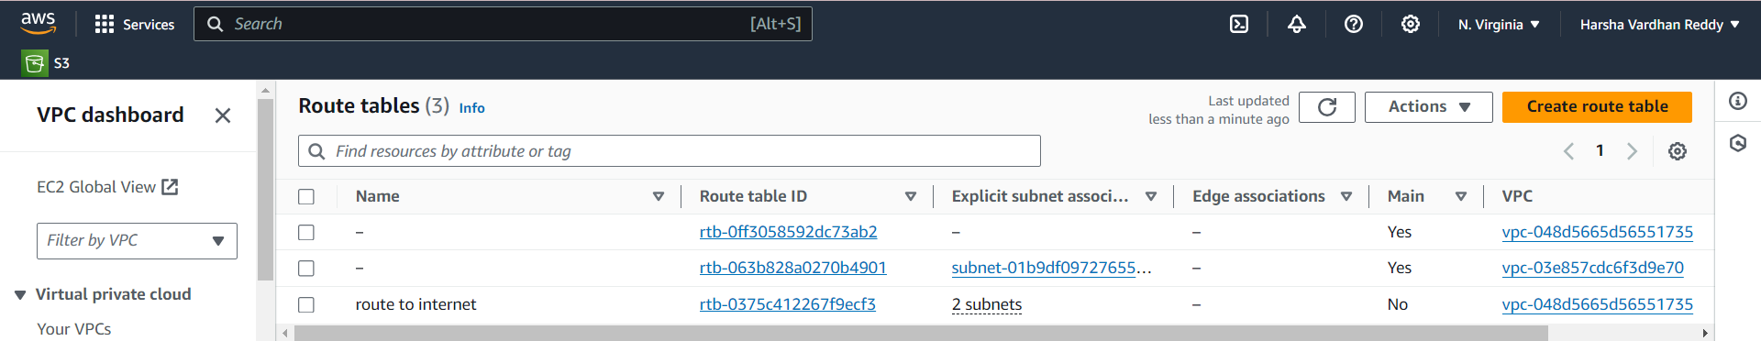

#SECURITY_GROUPS--------------------

Ec2instance.tf

resource "aws_security_group" "security_today" {

name = "today-security"

description = "Dev VPC web"

vpc_id = aws_vpc.harsha-project.id

ingress {

description = "Allow Port 80"

from_port = 80

to_port = 80

protocol = "tcp"

cidr_blocks = ["0.0.0.0/0"]

}

ingress {

description = "Allow Port 22"

from_port = 22

to_port = 22

protocol = "tcp"

cidr_blocks = ["0.0.0.0/0"]

}

ingress {

description = "Allow Port 443"

from_port = 443

to_port = 443

protocol = "tcp"

cidr_blocks = ["0.0.0.0/0"]

}

egress {

description = "Allow all ip and ports outbound"

from_port = 0

to_port = 0

protocol = "-1"

cidr_blocks = ["0.0.0.0/0"]

}

}

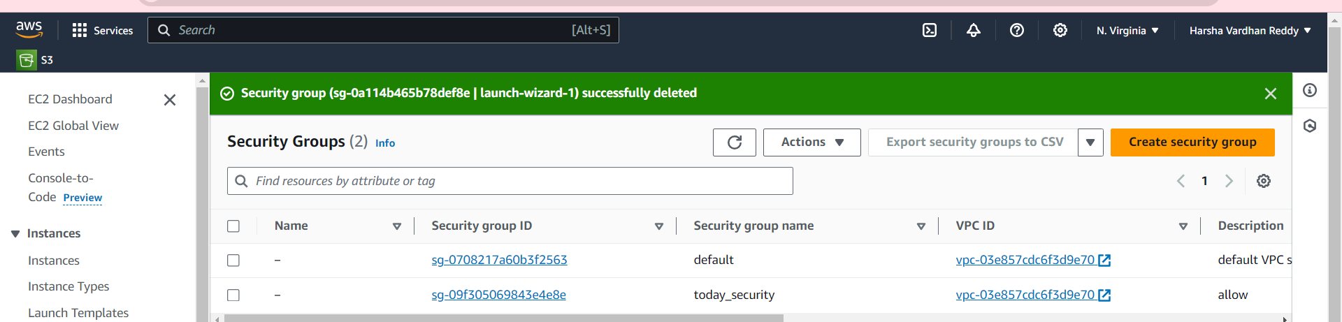

#EC2_INSTANCE----------------

resource "aws_instance" "harsha_instance" {

ami = "ami-066784287e358dad1"

instance_type = "t2.micro"

vpc_security_group_ids = [aws_security_group.security_today.id]

subnet_id =aws_subnet.public_subnet_1.id

key_name = "l-b"

user_data = file("apache-install.sh")

tags = {

Name = "today-project"

}

}

resource "aws_instance" "harsha_instance_1" {

ami = "ami-066784287e358dad1"

instance_type = "t2.micro"

vpc_security_group_ids = [aws_security_group.security_today.id]

subnet_id =aws_subnet.public_subnet_2.id

key_name = "l-b"

user_data = file("apache-install.sh")

tags = {

Name = "today-project_1"

}

}

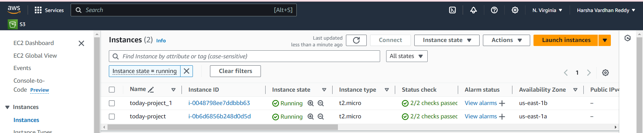

#TARGET GROUP CREATE--------------

Targetload.tf

resource "aws_lb_target_group" "target-group" {

name = "harshatargetgroup"

port = 80

protocol = "HTTP"

vpc_id=aws_vpc.harsha-project.id

health_check {

path = "/health"

port = 80

protocol = "HTTP"

}

}

#LOAD BALANCER CREATE-----------

resource "aws_lb" "project_alb" {

name = "loadharsha"

internal = false

load_balancer_type = "application"

security_groups = [aws_security_group.security_today.id]

subnets = [aws_subnet.public_subnet_1.id, aws_subnet.public_subnet_2.id]

}

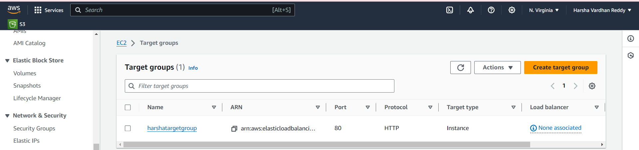

# ATTACHMENT TARGET GROUP TO LOADBALANCER-----------

resource "aws_lb_target_group_attachment" "attachment" {

target_group_arn = aws_lb_target_group.target-group.arn

target_id = aws_instance.harsha_instance.id

port = 80

depends_on = [

aws_lb_target_group.target-group,aws_instance.harsha_instance,

]

}

resource "aws_lb_target_group_attachment" "attachment_1" {

target_group_arn = aws_lb_target_group.target-group.arn

target_id = aws_instance.harsha_instance_1.id

port = 80

depends_on = [

aws_lb_target_group.target-group,aws_instance.harsha_instance_1,

]

}

resource "aws_lb_listener" "listener_elb" {

load_balancer_arn = aws_lb.project_alb.arn

port = 80

protocol = "HTTP"

default_action {

type = "forward"

target_group_arn = aws_lb_target_group.target-group.arn

}

}

#OUTPUT BLOCK---------------------------

Output.tf

#dns of load balancer----------------

output "lb_dns_name" {

description = "DNS of Load balancer"

value = aws_lb.project_alb.dns_name

}

# ec2_instance public ip-------------------

output "instance_public_ip" {

description = "Public IP address of the EC2 instance"

value = aws_instance.harsha_instance.public_ip

}

output "instance_public_1_ip" {

description = "Public IP address of the EC2 instance"

value = aws_instance.harsha_instance_1.public_ip

}

